W1 PRACTICE
MOBILE UX – PROJECT – PART 1

By: Ory Chanraksa & Sao Visal (SE-G4)



W1 PRACTICE
MOBILE UX – PROJECT – PART 1

In this project, you will work on a bike rental mobile application inspired by a real municipal service (Toulouse, France) which does not work so well.

The application allows users to:
- Locate bike stations
- Rent and return bikes
- Manage subscriptions
- Understand pricing and usage rules (but should they really understand that…)

You will find the application specification on this document.
Your role is not to correct the specification, but to analyze, structure, and transform it into a clear UX foundation.

You will progressively move from business understanding to user stories, and jump to user flows and sitemap to specify the information architecture.
Next week you will continue with the Wireframe and widgets usages

https://play.google.com/store/apps/details?id=com.jcdecaux.vls.toulouse

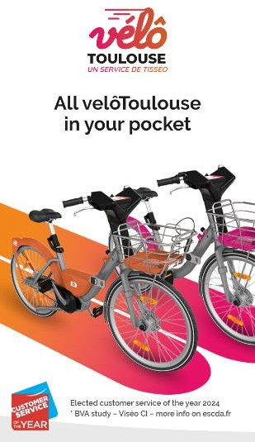
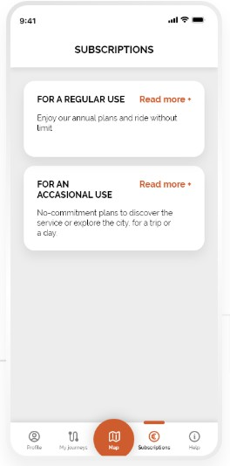
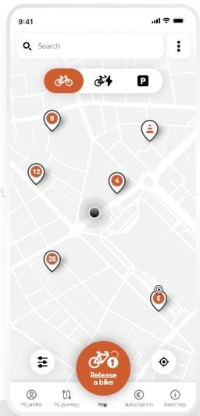
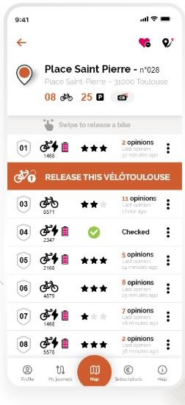
Your goal is to improve an existing app by understanding the user flows and pains

EXPECTED OUTCOMES

1 – BUSINESS ANALYSIS
Read, understand the specifications, and represent the business concepts using mindmaps.

- Clarify the business taxonomy (definition.)
- Clarify the business concepts relationships (mind map)
- Clarify the business flow (flow diagrams)

⚠️ Be able to identify what is really important, duplicated information etc.
- Station: Physical docking points located throughout the city with a specific name and ID .
- Mechanical Bike: Standard city bike without electrical assistance .
- Electric Bike: Bike with battery assistance; availability depends on battery level and station.
- Dock (Block): A physical slot at a station used to secure a bike .
- Trip: The period starting from a successful unlock until the bike is locked at a station .
- Subscription: Long-term access (annual or monthly) .
- Pass: Short-term access (day pass or single trip) .
- Free Usage Duration: A set time (like 30 mins) where the trip cost is $0, depending on the subscription type.
- Subscription status: the current state of a subscription (Active, Expired, Suspended, or Pending…).
- Operational status: whether a station is open or closed for maintenance.

Business/entities relationship

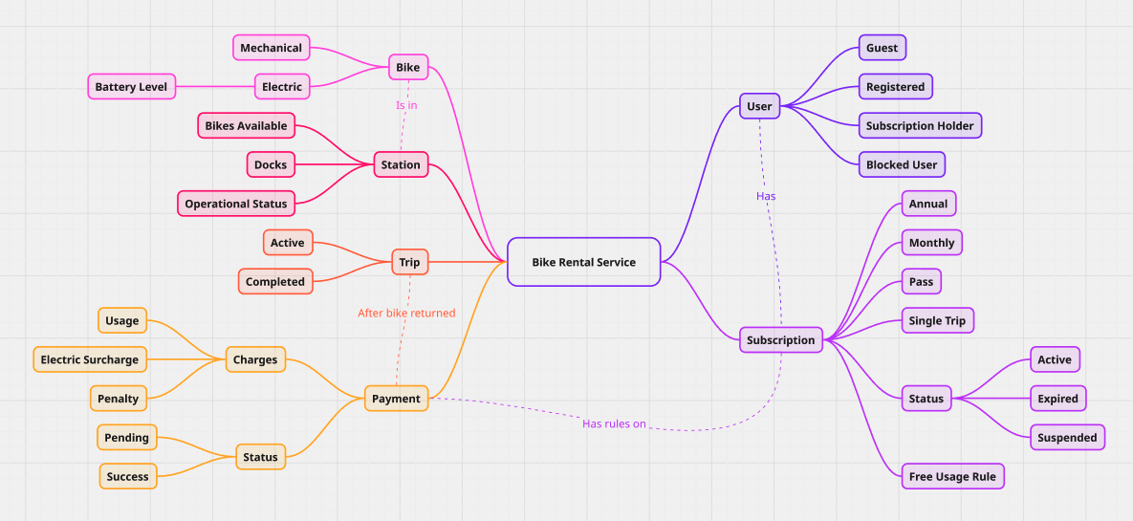

Modeled by the key taxanomies and how it relates to each other.

Business flow (system level)

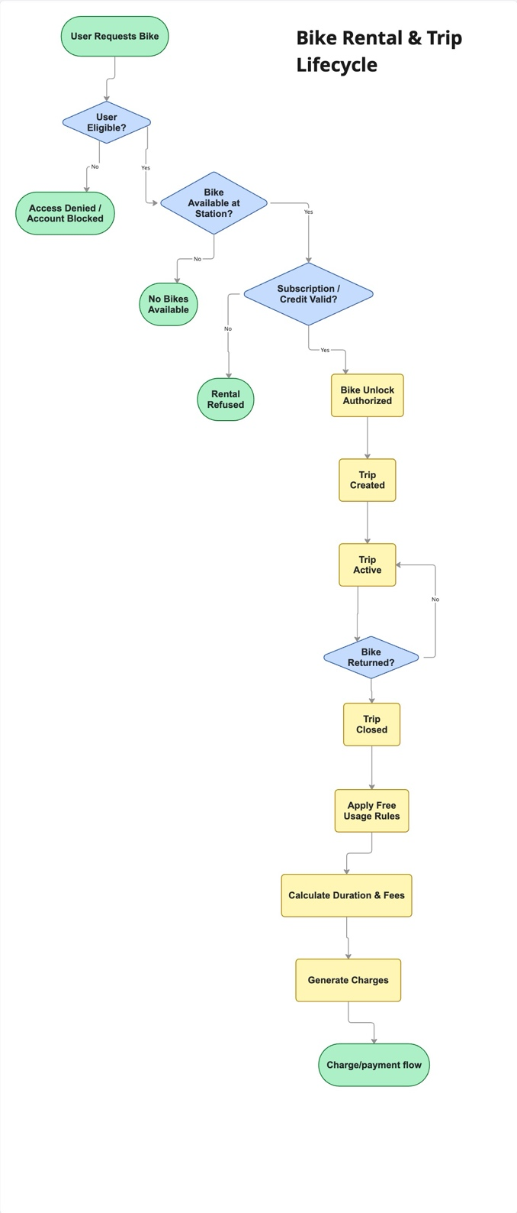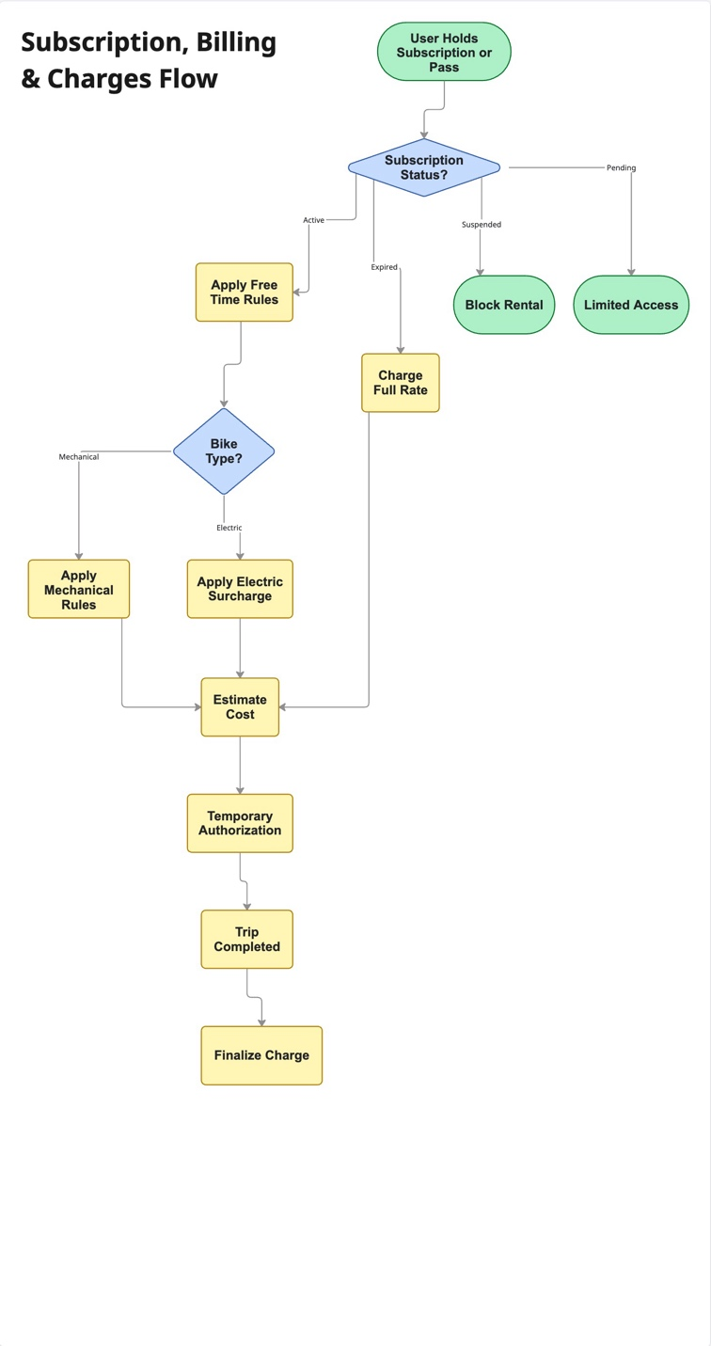

Note: This is not Ui (like tap or buttons) just core flow.

2 – PROFILES & USER STORIES
Based on the specification, identify and describe representative user profiles, reflecting:
- Different usage frequencies
- Subscription status
- Motivations and constraints
• Resident Commuter: Uses the service daily; likely holds an annual subscription and might have both personal and professional accounts.
• Occasional Local: Uses the service for specific errands; focuses on "Occasional Use" passes.
• Tourist: New to the city; needs immediate info on pricing, rules, and single-trip options without a long-term commitment.
• Electric-Only Rider: Specifically looks for assisted bikes and is willing to pay surcharges.

Translate business needs and user goals into user stories.
- As a user, I want to see the battery level of electric bikes so I don't pick one that will die mid-trip.
- As a user, I want to know before unlocking a bike whether my subscription or credit allows me to start a trip, so I don’t encounter an unexpected error.
- As a user, I want to review my past trips and their final charges so I can understand and trust the billing.
- As a resident, I want to switch between my personal and professional subscriptions so I can bill my trips correctly.
- As a rider returning a bike, I want to see stations with free docks rather than available bikes so I can end my trip quickly.
- As a new user, I want to see the stations on a map without logging in so I can check if the service is useful to me.
- As a subscriber, I want to know exactly when my 30 free minutes end so I can avoid extra charges .
- As a subscriber, I want to know if extra charges apply when choosing an electric bike so I can make an informed decision.
- As a user with a failed return, I want an immediate alert if my trip is still active even though I docked the bike.
- As a user with a blocked account, I want to know if it is due to unpaid fees so I can resolve it immediately.

What are the pain points of the existing app for the user? (see user feedback below)
• Vague Errors: Users experience errors but are not given a clear reason for them.
• Disconnected Flow: Users try to book a bike, realize they lack credit, and are forced to leave the booking flow to find subscription management.
• Unclear Pricing: The relationship between bike booking and subscription types is confusing for users .
• Wrong Map Focus: When returning a bike, the app prioritizes showing available bikes instead of empty docks.
• Sync Issues: The bike may be physically returned, but the app keeps the trip active, leading to overcharging .
• Notification Overload: Messages may appear multiple times or in non-contextual sections.
• Multiple Charges: Users sometimes end up with several charges for a single trip.

3 – USER FLOWS
Design the user flow diagrams for key scenarios (e.g. renting, returning the bike, checking consumed credits)
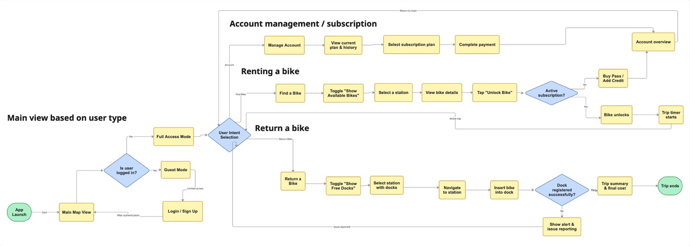
4 –SITE MAP
Design the sitemap of the application (the graph of pages/views and their interactions)

- Include the data and actions related to each pages/view.
- Specify the importance of each element
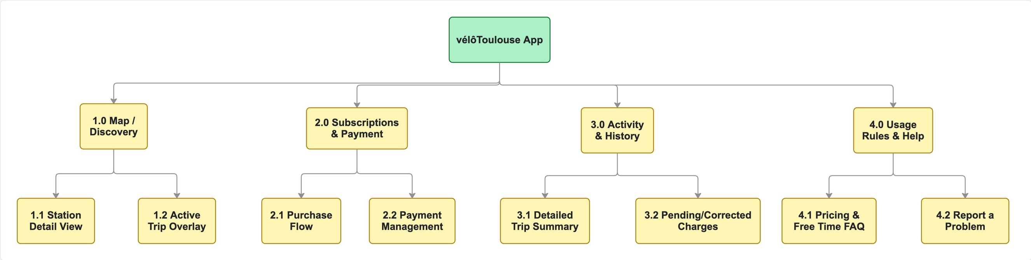

Note: ⭐ = priority/importance

1.0 Map / Discovery (Main View) ⭐⭐⭐
Purpose: Core service usage (rent & return) see all the bikes, the stations (core business)

Data
- Interactive city map with station pins
- Station name & ID
- Available bikes (Mechanical / Electric)
- Electric bike battery level (indicative)
- Free docks available
- Station status (Open / Maintenance)

Key Actions
- Search location or station
- Toggle Find a Bike / Find a Dock
- Filter by bike type
- Access user account

Sub-pages
1.1 Station Detail View
- Data: bike counts, dock availability, station status
- Actions: select bike / view issues
1.2 Active Trip Overlay
- Data: trip timer, estimated cost, battery warnings
- Actions: end trip guidance, error feedback

2.0 Subscriptions & Payment ⭐⭐
Purpose: Access rights & billing

Data
- Subscription type & status
- Free usage rules summary
- Account alerts (blocked / unpaid fees)

Key Actions
- Buy / renew subscription
- Manage payment method
- Switch subscription profile

Sub-pages
2.1 Purchase Flow
- Data: available plans, pricing rules
- Actions: confirm purchase
2.2 Payment Management
- Data: stored cards, pending authorizations
- Actions: add / remove payment method

3.0 Activity & History ⭐⭐
Purpose: for record saving

Data
- List of past trips
- Duration & cost per trip
- Estimated vs final charges

Key Actions
- Access trip details
- Review billing issues

Sub-pages
3.1 Trip Detail
- Data: timeline, bike type, cost breakdown
- Actions: report issue
3.2 Pending / Corrected Charges
- Data: adjustments, penalties
- Actions: review explanations

4.0 Usage Rules & Help ⭐
Purpose: Reduce confusion & handle errors

Data
- Free time rules (per trip / per day)
- Over-usage fees
- Return & locking instructions

Key Actions
- Access help articles
- Report problems

Sub-pages
4.1 Pricing & Free Time FAQ
- Data: simplified rule explanations
- Actions: navigate to related topics
4.2 Report a Problem
- Data: issue categories
- Actions: submit report

APPLICATION SPECIFICATION

1 – Context & Purpose
The city operates a station-based bike rental service allowing users to rent electric or mechanical bikes
from docking stations distributed across the city.

The service is accessible through a mobile application, which enables users to:
- Access information about bikes and stations
- Rent and return bikes
- Manage subscriptions and payments
- Consult ride history and charges

The application is intended for:
- Residents
- Occasional users
- Tourists
- Users with or without subscriptions
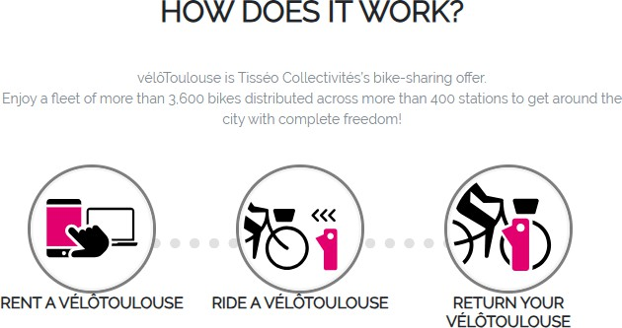

For more information, read the official website.

https://velotoulouse.tisseo.fr/en/home https://velotoulouse.tisseo.fr/en/mapping

Bike Types
The service provides two types of bikes:

Mechanical Bikes
  - Standard city bikes
  - No electrical assistance
  - Available at most stations
  - Subject to free usage duration depending on subscription

Electric Bikes
  - Electrically assisted bikes
  - Limited availability depending on station
  - Additional charges may apply depending on subscription and usage duration
  - Battery level varies and may affect availability

Some stations may:
  - Contain only mechanical bikes
  - Contain only electric bikes
  - Contain a mix of both
  - Temporarily contain no bikes

Stations
Stations are physical docking points located throughout the city.
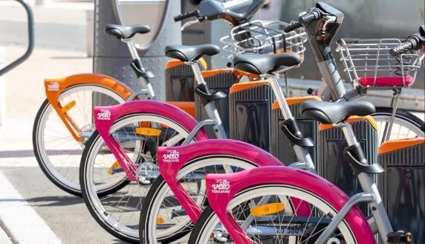

Each station:
  - Has a name and identifier
  - Has a fixed number of docks
  - May have available bikes and/or free docks
  - Can be temporarily unavailable due to maintenance or technical issues

Station information includes:
  - Number of available mechanical bikes
  - Number of available electric bikes
  - Number of free docks
  - Station operational status

Users
Users may:
  - Use the service occasionally
  - Hold multiple subscriptions at the same time (e.g. personal + professional)
  - Switch phones or reinstall the app
  - Have unpaid fees or blocked accounts

Some features may be accessible without logging in. Suh as viewing the stations on the map and their status.

Subscriptions & Passes
The service offers several types of subscriptions and passes.

Subscription Types
  - Annual subscription
  - Monthly subscription
  - Day pass
  - Single trip (no subscription)

Subscriptions may:
  - Be active, expired, suspended, or pending
  - Apply differently to mechanical and electric bikes
  - Include free usage time (e.g. first 30 minutes free)

⚠️ The notion of “first 30 minutes free” may apply:
  - Per trip
  - Per day

Free Usage Rules (Indicative)
  - Some subscriptions include 30 minutes free per trip
  - Some include 30 minutes free only on mechanical bikes
  - Some include no free time on electric bikes
  - Free time resets after bike return
  - Free time does not carry over

Rental & Trip Rules
A trip starts when:
  - A bike is successfully unlocked from a station A trip ends when:
  - The bike is properly returned and locked at a station

Trips:
  - Are billed based on duration
  - May include additional fees for electric bikes
  - May incur penalties if not returned correctly

Users can:
  - Rent only one bike at a time per account
  - Return a bike to any compatible station
  - Be charged extra if the bike is not returned within a maximum duration

Some errors may occur:
  - Bike appears returned but trip remains active
  - Dock does not register return immediately
  - User ends up with multiple charges for the same trip

Payments & Charges
Payments are required for:
  - Subscription purchases
  - Usage beyond free time
  - Electric bike surcharges
  - Penalties or extra fees

Payment methods may include:
  - Credit/debit card
  - Stored payment method
  - Temporary payment authorization

Charges may:
  - Appear immediately
  - Appear after trip completion
  - Be grouped at the end of the day
  - Be corrected later

Users may see:
  - Estimated cost
  - Final cost
  - Pending charges

Notifications & Messages
The application may display:
  - Informational messages
  - Alerts
  - Warnings
  - Error messages Examples:
  - “30 minutes free included”
  - “Electric bike surcharge may apply”
  - “No bikes available at this station”
  - “Trip still active”

Messages may:
  - Appear multiple times
  - Appear in different sections
  - Not always be contextual

- Edge Cases & Constraints
The system must handle:
  - Users with no subscription
  - Users with multiple active subscriptions
  - Stations with bikes but no free blocks
  - Stations with free blocks but no bikes
  - Battery depletion during trip
  - App closed during active trip
  - Network loss during unlock or return
  - Account blocked due to unpaid fees

- User Feedback on existing application

  - Many errors occur without understanding their reasons
    - Most of the time it’s due to lack of credit, as the link btw bike booking and subscription is unclear

  - The subscriptions are unclear to understand
  - The flow is not clear as when we book a bike without enough credit, we need to come back to the subscription management etc.

  - When we return a bike, what we want to see is the free blocks to return it, not the available bikes…

